2023

Sajeda Haikal

ASU

1/1/2023

SDD documentation

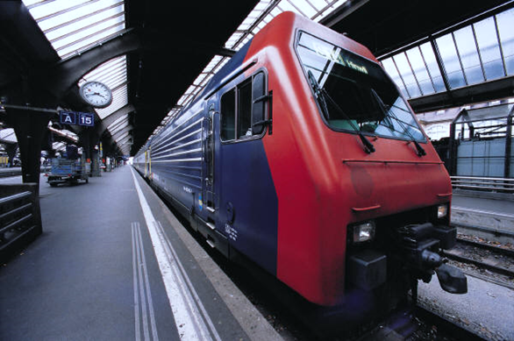

Contents

Introduction 2

System Description 2

System Component 2

Component1 2

Component 2 2

Component 3 2

User Details 3

System Component2 3

Component12 3

Component 22 3

Component 3 2 3

conclusion 3

# Introduction

Asgehrdtfgkjfhdsfghj

# System Description

Sdfghdjfk;ljkhjghfsafdsg

# System Component

Sdfghdjfk;ljkhjghfsafdsg

## Component1

Sdfghdjfk;ljkhjghfsafdsg

## Component 2

Sdfghdjfk;ljkhjghfsafdsg

## Component 3

Sdfghdjfk;ljkhjghfsafdsg

# User Details

Sdfghdjfk;ljkhjghfsafdsg

# System Component2

Sdfghdjfk;ljkhjghfsafdsg

## Component12

Sdfghdjfk;ljkhjghfsafdsg

## Component 22

Sdfghdjfk;ljkhjghfsafdsg

## Component 3 2

Sdfghdjfk;ljkhjghfsafdsg

# conclusion